Empower ID - Password Reset/Unlock

Empower ID is a program that will allow you to easily reset your password and unlock your account either on your KHE issued computer or from the internet on any computer. Since you can now reset your password and unlock your account online it will help you when you are trying to access the network from a home computer.

If you are a first time visitor to the Empower ID site you MUST first register to use the site.

Go to the Password Manager Empower ID (Dot Net Factory) URL https://pwr.kaplan.edu
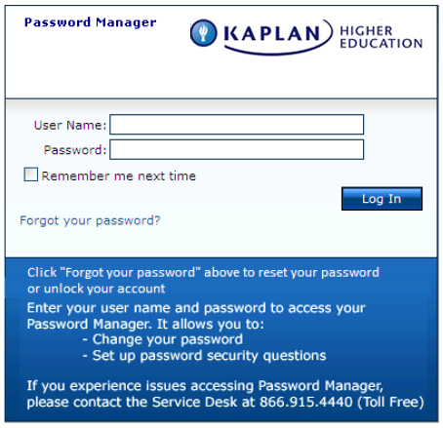

Enter your current Charlie User Name and Password

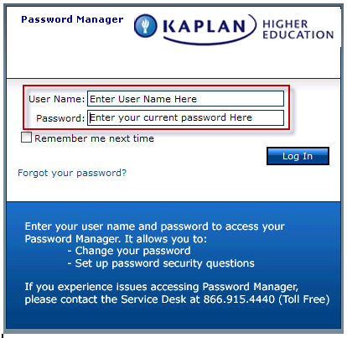

Click on Log In

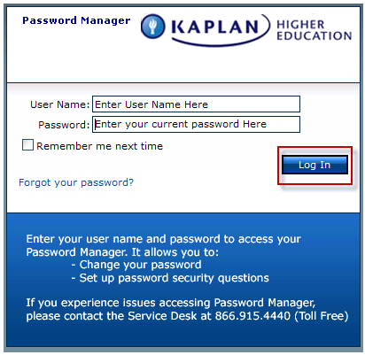

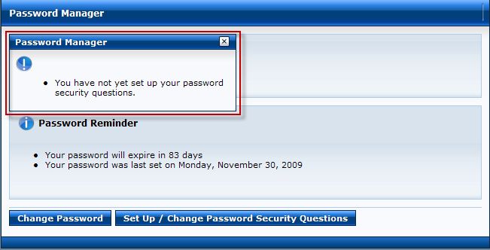

You will see this message “You have not yet set up your password security questions”. The message will go away in seconds
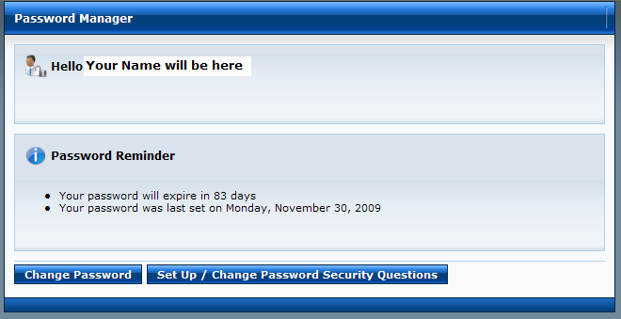

Click on Set Up / Change Password Security Questions
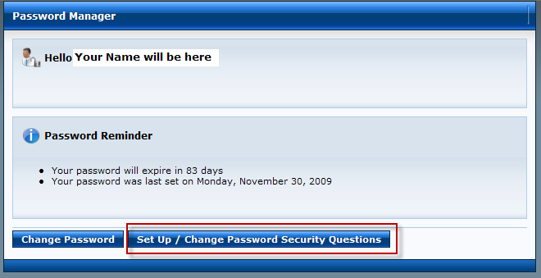

There are 4 questions in total that need to be answered
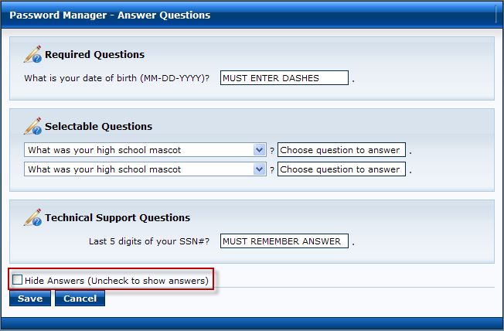
Make sure the green check mark is removed from this box so you can see what your typing is correct
You must answer all the questions on this page to register for the Password Manager
Required Questions:
What is your date of birth (MM-DD-YYYY)
Enter dashes in your date of birth exactly as shown in example

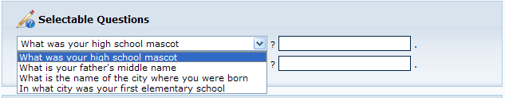
Selectable Questions:
You must select 2 of the 4 selectable questions
Each Selectable Questions drop down menu has the same questions listed
What was your high school mascot?
What is your father’s middle name?
What is the name of the city where you were born?
In what city was your first elementary school
You can only pick each question 1 time
You can only use an answer 1 time
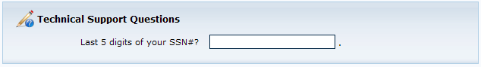
Your Last 5 digits of your SS# is the security questions you will be asked by the Service Desk if you call to reset your password because you have forgotten you security questions. You must remember this number. The Service Desk cannot change it.
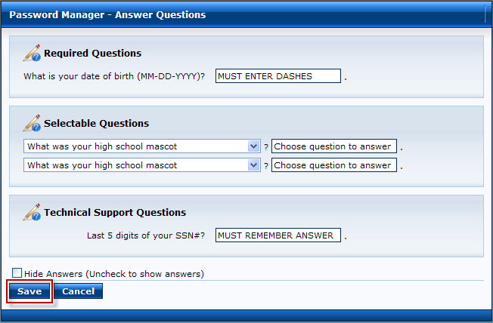
After completing the questions click Save
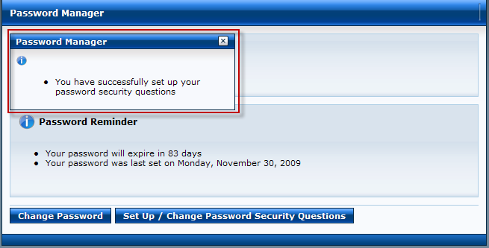
Once the enrollment is complete, the message “You have successfully set up your password security questions” will be displayed. You can close this window.

You will also receive the below email from PWReset@kaplan.edu

